How To Install Windows 10 Hands-On

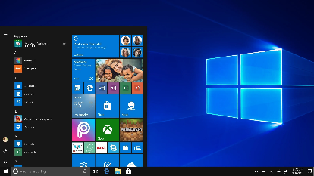

Project Summary:

The Windows 10 operating system is easy to install on modern hardware. However, there are lots of choices to make during the process, which can be a little confusing until you have some experience. This project gives you that experience with the chance to try things or make mistakes on one of our X lab computers, rather than on your PC, so no worries.

Parts Needed:

A Lab X-Series PC

Windows 10 Installation USB Drive

*Insert Parts Picture Here*

Step-by-Step Directions:

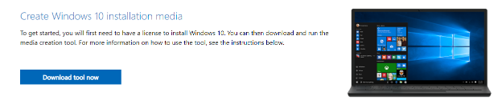If you do not have a Windows 10 Installation USB drive, it is easy to make one. Microsoft has a tool that will download the files needed and setup the USB drive: <https://www.microsoft.com/en-us/software-download/windows10> If you are in Gatway’s Advance Cyber Systems Lab, you are welcome to use our pre-configured USB drive for lab activities.

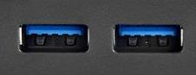

First, plug the USB flash drive with Windows 10 into a USB port on the computer that is going to get a new operating system.

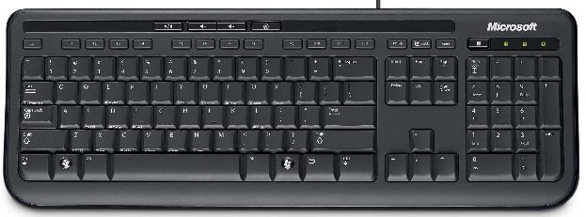

On most computers, we need to hit a key while the computer is booting up to get to the boot device menu. This is how we tell the PC to look at the USB flash drive instead of running whatever is on the hard drive. The common keys are **Esc** or **F10** or **F12** but some machines will use something different, so a bit of web searching with the model of the PC might be needed.

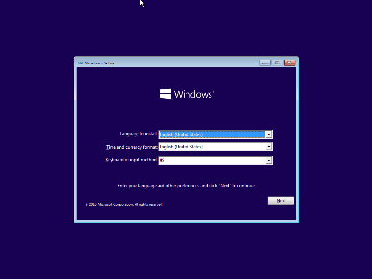

After the USB Flash Drive has been selected, the PC should start the Windows install process. The first screen to come up will give you the ability to change language and keyboard related options. The default settings are the most common for folks in the USA, so click the **Next** button to continue the process.

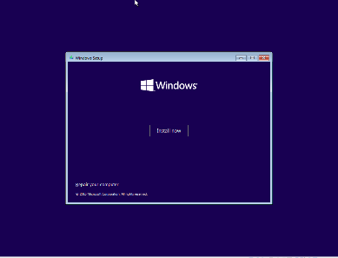

The Repair your computer option might be useful in the future, but the **Install Now** option is the one we want to pick now for an install.

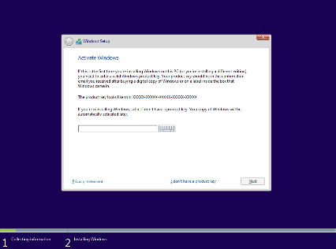

If you have a product key from Microsoft, this is where that information is typed in to register the installation. However, we can practice installing and using Windows 10 without a key by choosing the **I don’t have a product key** option in the fine print at the bottom of the page.

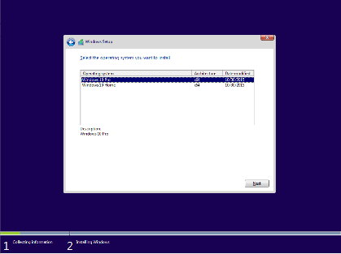

Microsoft give us the option to either install Windows Pro or Windows Home edition from the same process. Unless there is a reason to pick Home, choose **Windows 10 Pro** and then click **Next** to continue.

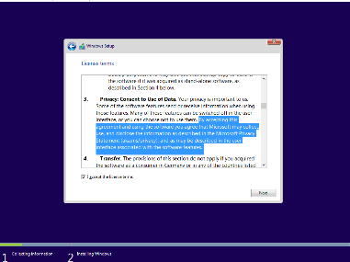

After reading the license terms, **check the box** to accept the agreement. Do note that “3. Privacy; Consent to Use of Data” gives Microsoft the right to collect information in a potentially very broad manner. Click **Next** to continue.

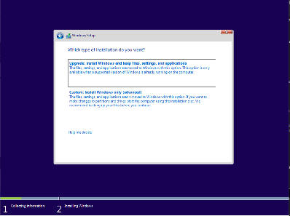

Choose the **Custom: Install Windows only** option so that we can have the most control over the installation process.

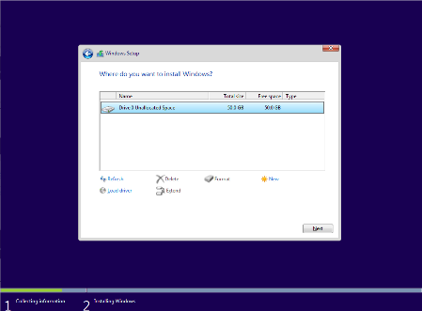

Now, we are going to choose the drive on which to install Windows 10. Your drive might be a different size, but 20GB is about as small as we can go. More space is better for functional installs so that there is room to install additional programs. However, it is not required for practice installations.

If there is an older operating system or files that need to be cleaned off, using the Delete and Format buttons will remove them. Click **Next** to move forward.

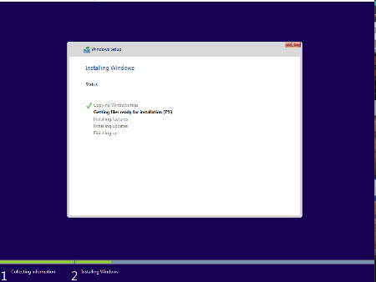

Windows 10 will start the installation process at this point. It can take a few minutes to run and does not require any interaction for a few minutes, until the system loads up.

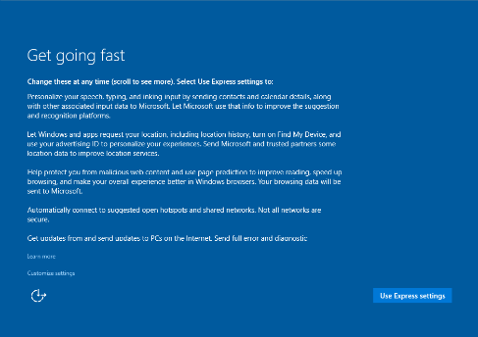

At this point, Microsoft really wants you to use their preferred settings, but they are likely not the best options. We will choose **Customize Settings** so that we can have as much control over the install as possible.

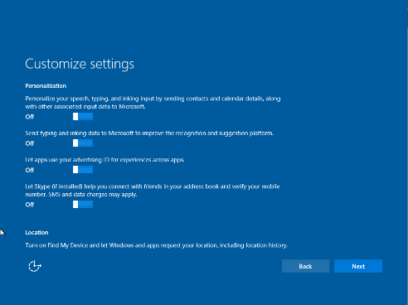

In general, unless there is a specific reason to leave an option turned on, it is best to turn them off for privacy purposes. When done, click **Next** to continue.

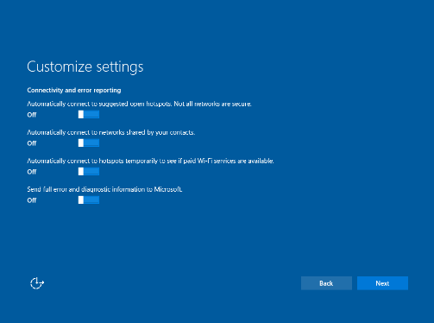

This is a similar situation where it is best to turn off options unless there is a specific reason to leave them on. When done, click **Next** to continue.

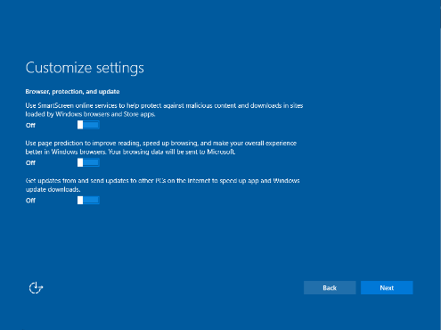

Again, off is the best option unless needed. When done, click **Next** to continue. This will restart the machine.

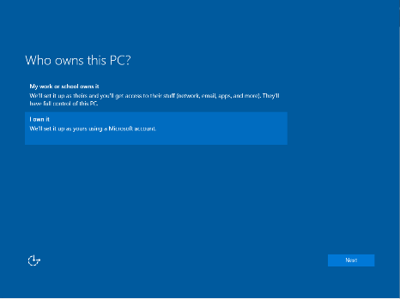

For this install, choose **I own it** unless this machine is going to be part of a business installation managed by a company.

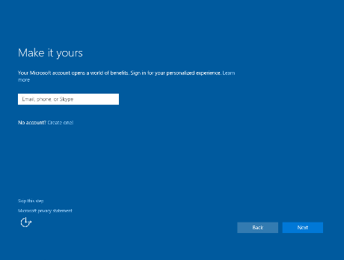

As we are trying our best to install Windows 10 with privacy in mind, we will choose the **Skip this step** option from the fine print at the bottom of the page.

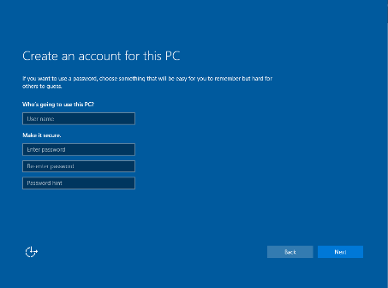

The **User Name** can basically be whatever you want. For the password, best practice is to pick three random words and string them together to make something easy to remember, but hard to guess, such as “PurpleKangarooKitchen”. If your **password** is something that would show up anywhere on your Facebook account, it is too simple and a bad choice. The **password hint** should not reveal too much information about the password that would make it easy to guess.

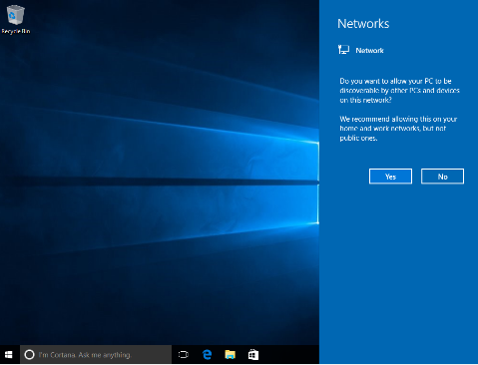

Unless you will need to share files, etc. on your home network, click the **No** button.

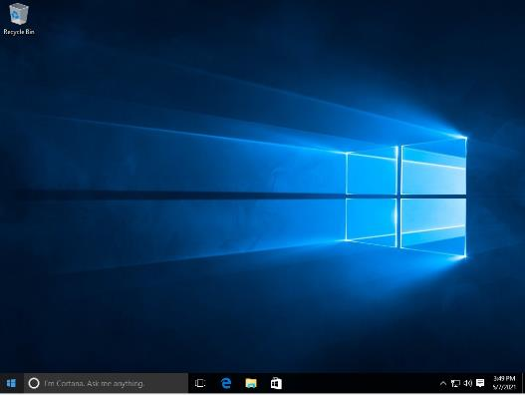

Now Windows 10 is up and running! Remove the USB flash drive from the system and enjoy the fruits of your labor.